The HC-SR04 ultrasonic ranging module is capable of 3mm resolution in the range 20-500mm. It requires a 5V supply. In operation, the module is triggered by delivering it a 10µs pulse. Some time later an “echo” pulse is generated whose length is proportional to the measured distance as illustrated in Figure 10.8 and defined by the following formula where pw is the echo pulse.

distance = pw ∗cm

58µs

We discussed how to generate a pwm output in Section 10.1 and now we leave it as an exercise to the reader to utilize timer

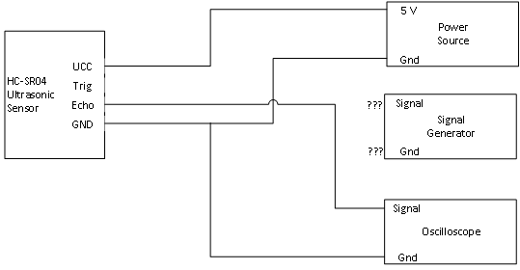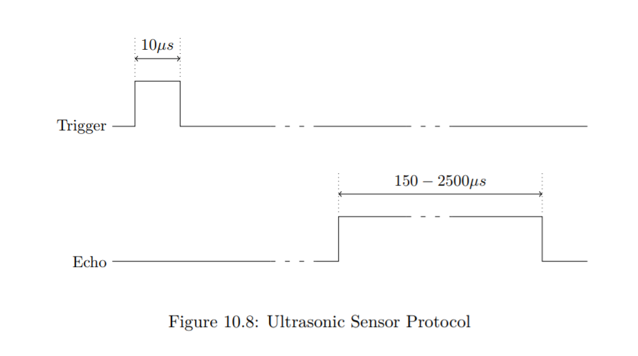TIM4 and Pin PB9 to generate trigger pulses at a 10Hz rate.